# CITP 155 – Programming I

## Functions Lab

## Graded Activity (20 points)

Provide any screen shots using the Snipping Tool and selecting only the relevant portion of the screen (instead of the entire screen). Provide any answers using a blue font. Please note that part of being a good programmer is being precise. If you have typos in your code, such as the words that are supposed to be displayed, you will not receive full credit.

KEEP ALL OF YOUR SOLUTION AND PROJECT FILES THROUGHOUT THE DURATION OF THE CLASS!

**Open your Visual Studio solution called Pets**

**Add a Visual C# Console Application project to the solution (2 points)**

Project Name: ListPets

Provide a screen shot of the New Project screen before clicking OK.

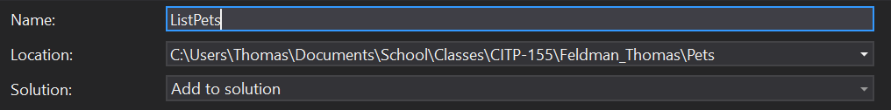

**Open and Modify Your C# Program**

Using the coding examples found at   
<https://csharp.net-tutorials.com/basics/functions/>   
<https://csharp.net-tutorials.com/basics/function-parameters/>   
as a guide, create a program that does the following:

* Create a function named **DogYears**. The function will be **static**, will return an **int**, will accept one int and will call that int **petAge**.
* The function will multiply petAge times 7 and return that result.
* In the Main method, write lines of code that will prompt the user for the age of their pet. Test your code. The results will look like this.  
  
* In the Main method, call the DogYears function to calculate the age of the pet in “dog years”. You will be passing in the value you just accepted from the end user.
* In the Main method, display the following to the console, concatenating together the appropriate static text and the appropriate variable.  
  **Your pet is xx years old in dog years.**  
  Replace xx with the calculation returned from the DogYears function.
* Test your program. Your results should look like this. You may or may not have the blank line on line three, depending on whether or not you left the ReadLine command there.  
  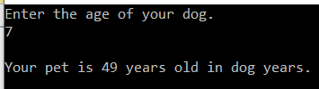
* Create a function named **CatYears**. The function will be **static**, will return an **int**, will accept one int and will call that int **petAge**.
* The function will multiply petAge times 4 and return that result.
* In the Main method, on the line right after calling the DogYears function, call the CatYears function to calculate the age of the pet in “cat years”. You will be passing in the value you just accepted from the end user. Your result from the two different functions need to be stored in two different variables.
* In the Main method, right after the line that displays the dog years to the console, display the following to the console, concatenating together the appropriate static text and the appropriate variable.  
  **Your pet is xx years old in cat years.**  
  Replace xx with the calculation returned from the CatYears function.
* Test your program. Your results should look like this. You may or may not have the blank line on line three, depending on whether or not you left the ReadLine command there.  
  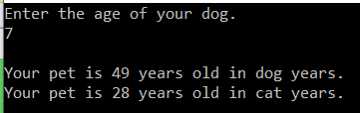

**Provide Results (18 points)**

Provide a screen shot of the console after you have tested your program. The screen shot should include the title bar of the console with the full path of the program. It should also include four lines of white text.

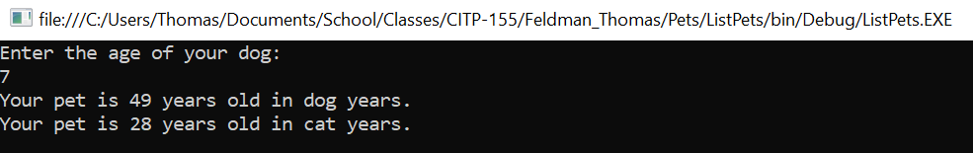

Copy and paste the lines of code from your program here. This is not a screen shot. This is code I can copy and paste to run on my own. This should be 25-35 lines of code, depending on how many blank lines you left in between other lines of code.

static void Main(string[] args)

{

int petAge;

Console.WriteLine("Enter the age of your dog: ");

petAge = Convert.ToInt32(Console.ReadLine());

Console.WriteLine("Your pet is " + DogYears(petAge) + " years old in dog years.");

Console.WriteLine("Your pet is " + CatYears(petAge) + " years old in cat years.");

Console.ReadLine();

}

public static int DogYears(int petAge)

{

int dogYears = petAge * 7;

return dogYears;

}

public static int CatYears(int petAge)

{

int catYears = petAge * 4;

return catYears;

}